**Step-1**

API Integration to Sanity by importing product data to Sanity.

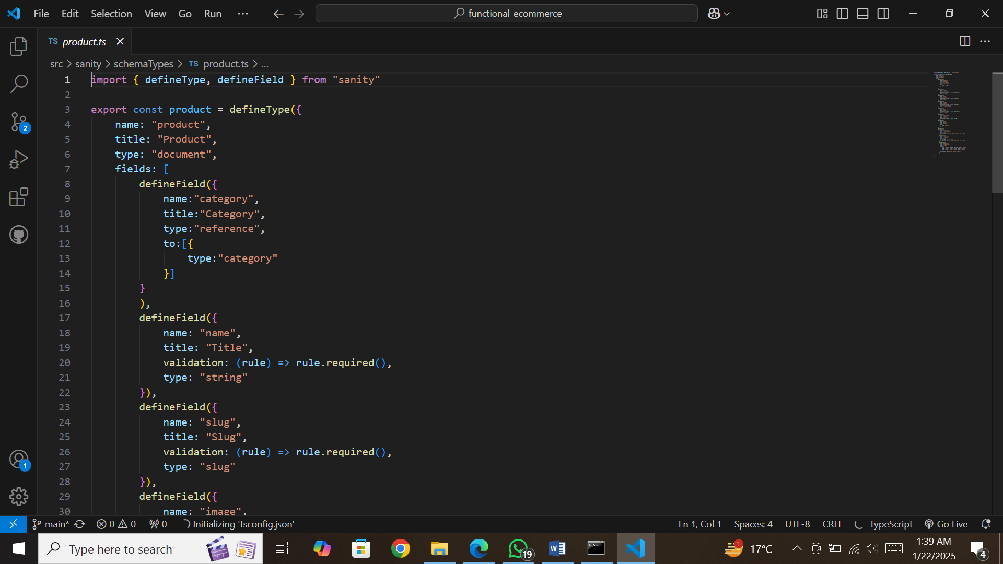

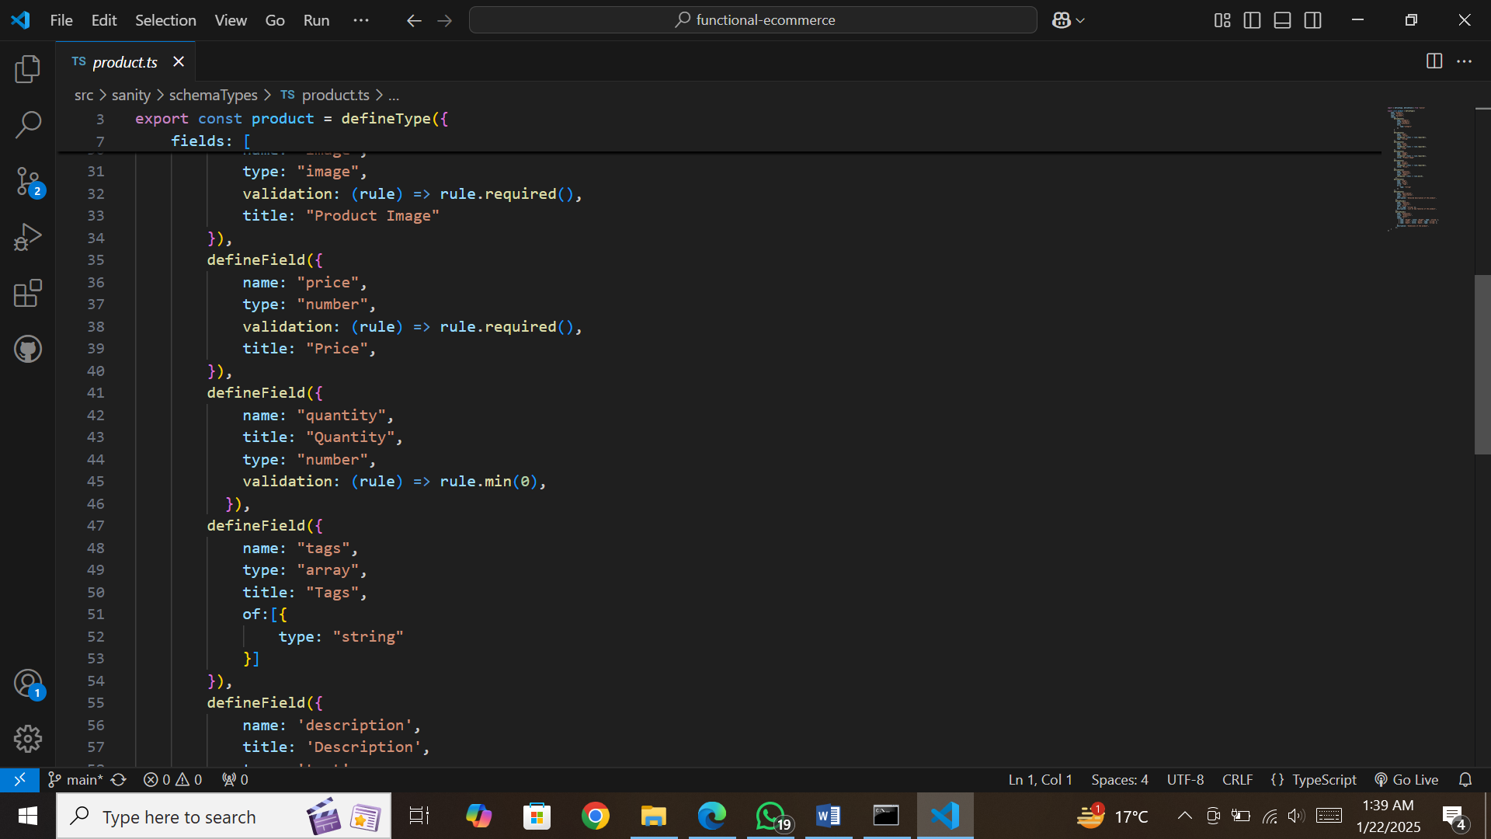

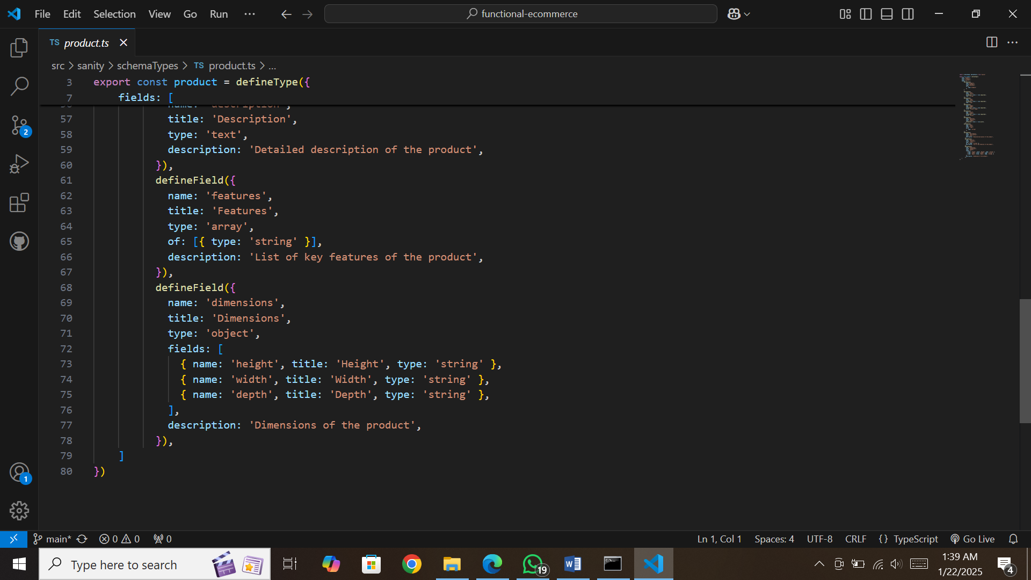

**Step-2**

Fetched data from Sanity on frontend to show my product data via Groq Querry.

* I made schemas of product and category.
* I fetched all products according to category.
* As my template has big number of categories, I fetched it dynamically.
* I created category component and category slug page.
* I fetched all my product through slug so that I could apply add to cart functionality to every product on my website.

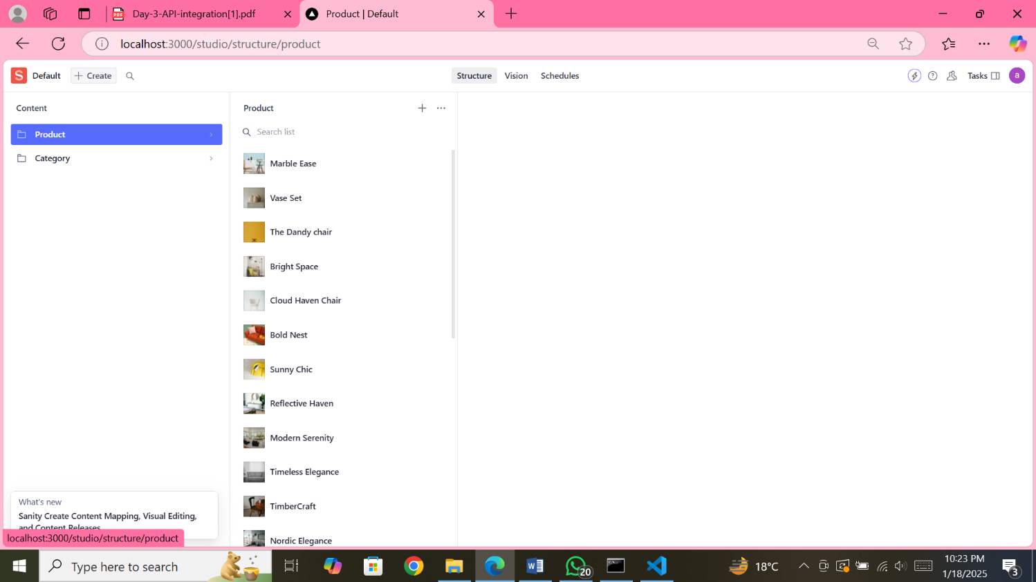

**Product Listing:**

I displayed my products according to categories by its name, color, price, review, discount price.

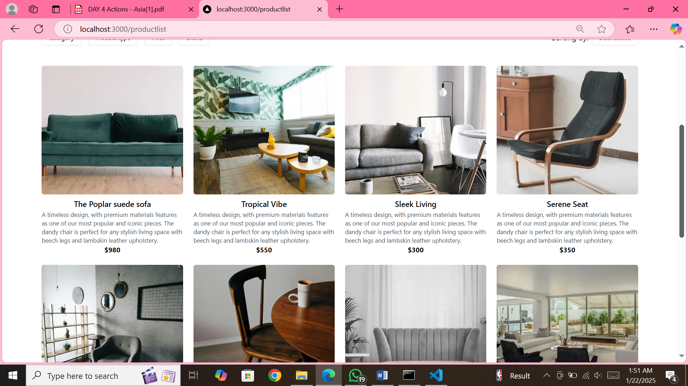

**Add To Cart Functionality**

* I have used react hook {useState and useEffect} for my add to cart button with dynamic and reuseable components of Quantity Button., PriceFormatter and PriceView.
* I created a dynamic cart page which is accessible after authentication. {I have put authentication by Clerks to my project at cart access}
* As I get access to cart page I can see total amount of shopped products even I can add more products over there by clicking Quantity Button or I can also remove any product, which I don’t want to keep.
* I have also made a section for the customer’s review, to make a review for our products on a product detail page.

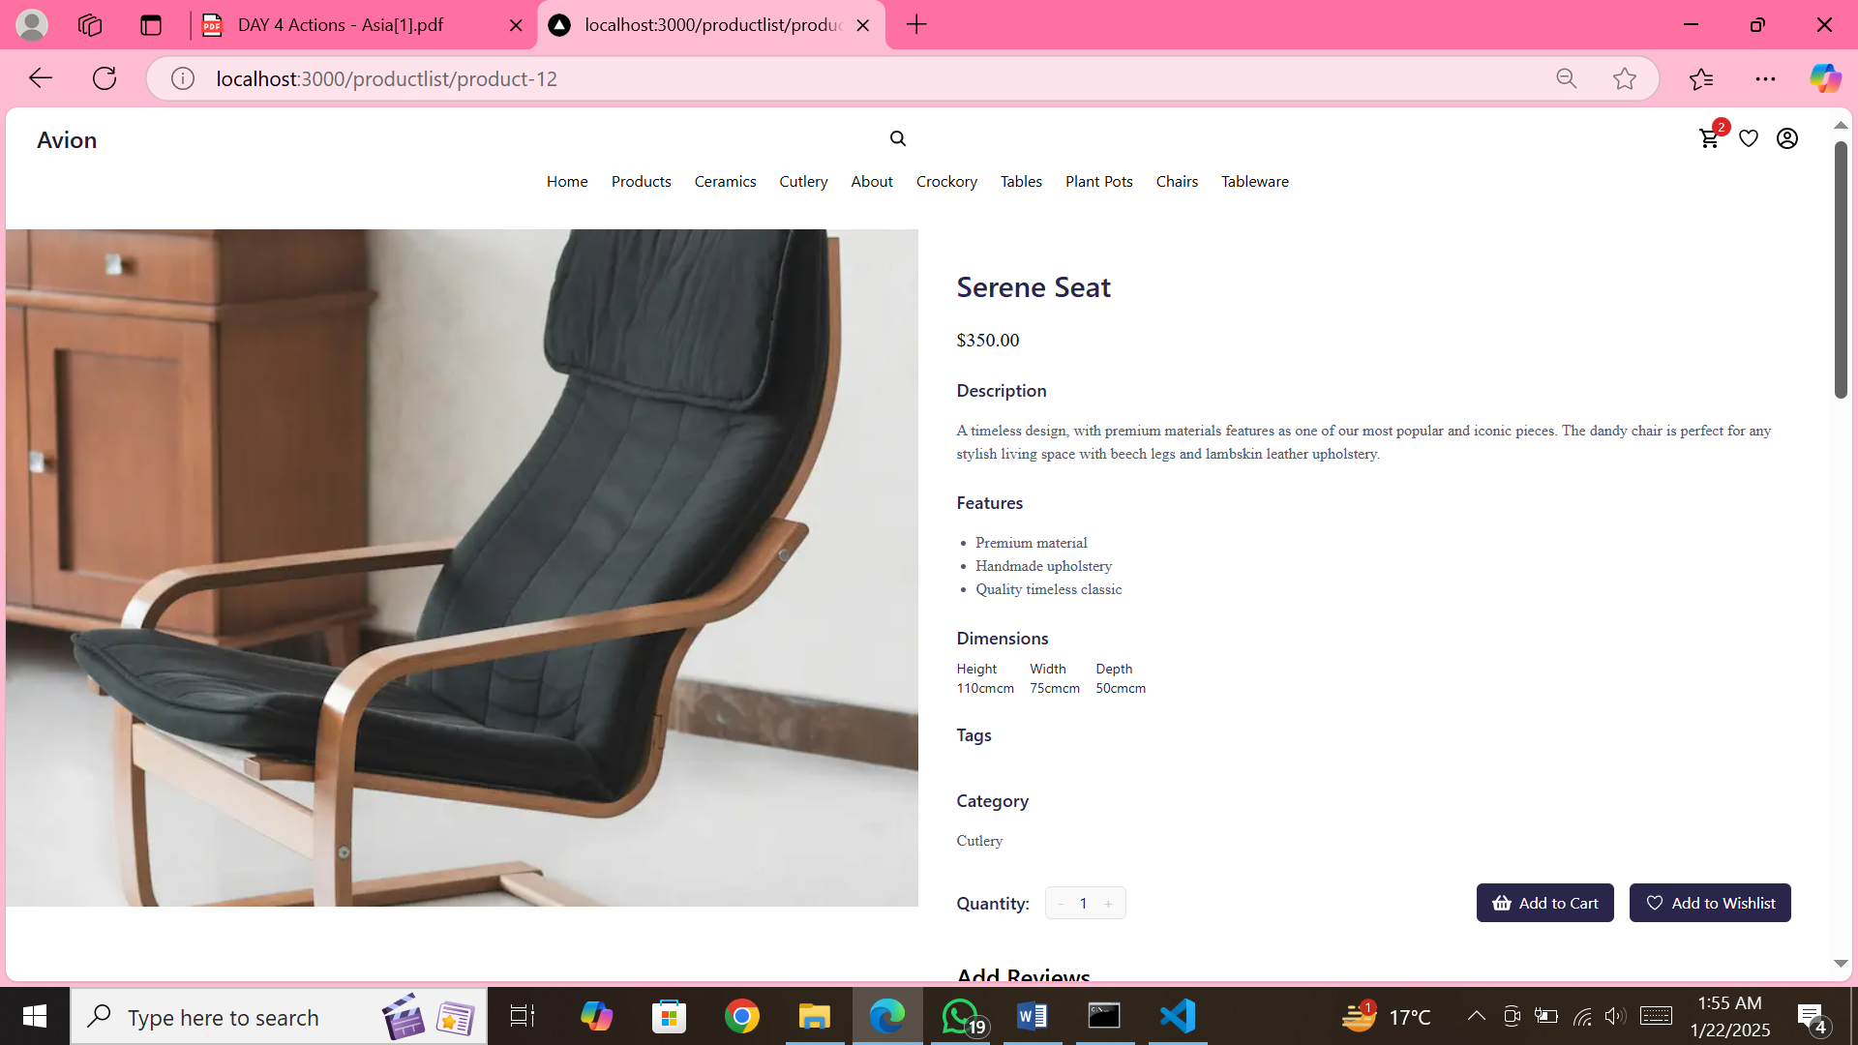

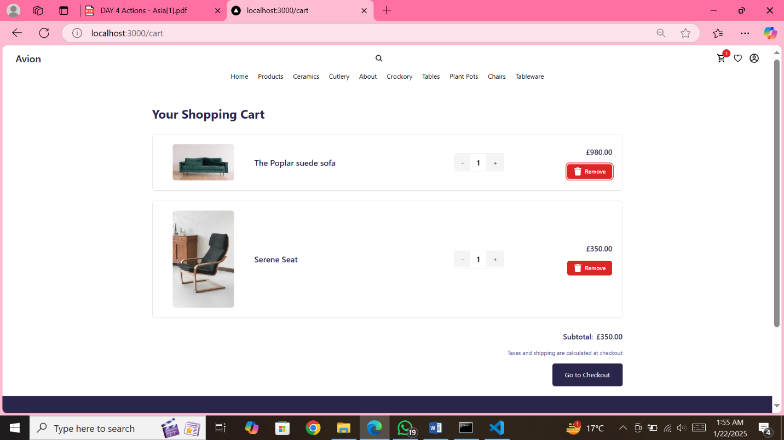

**ADD TO WISHLIST:**

I also add functionality of add to wishlist in my website.

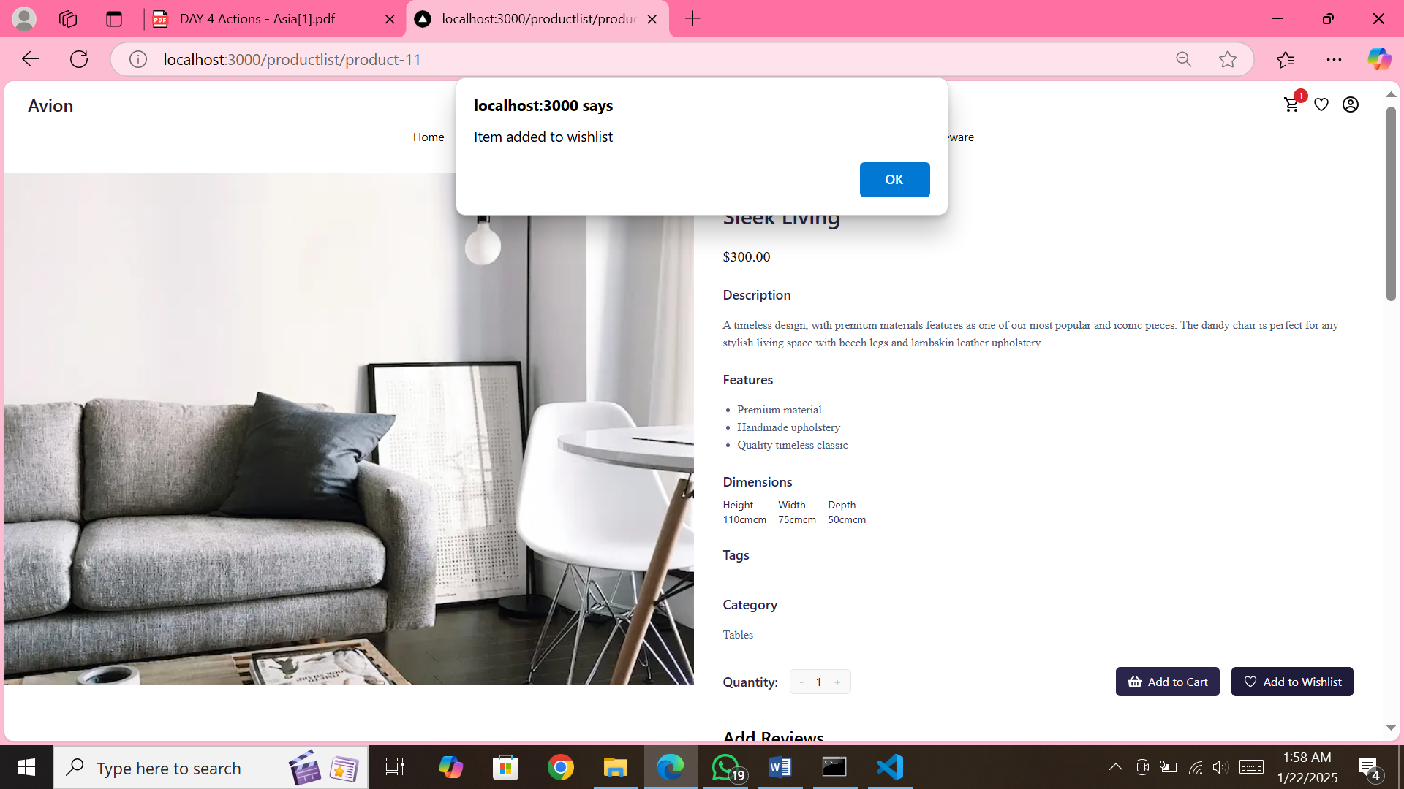

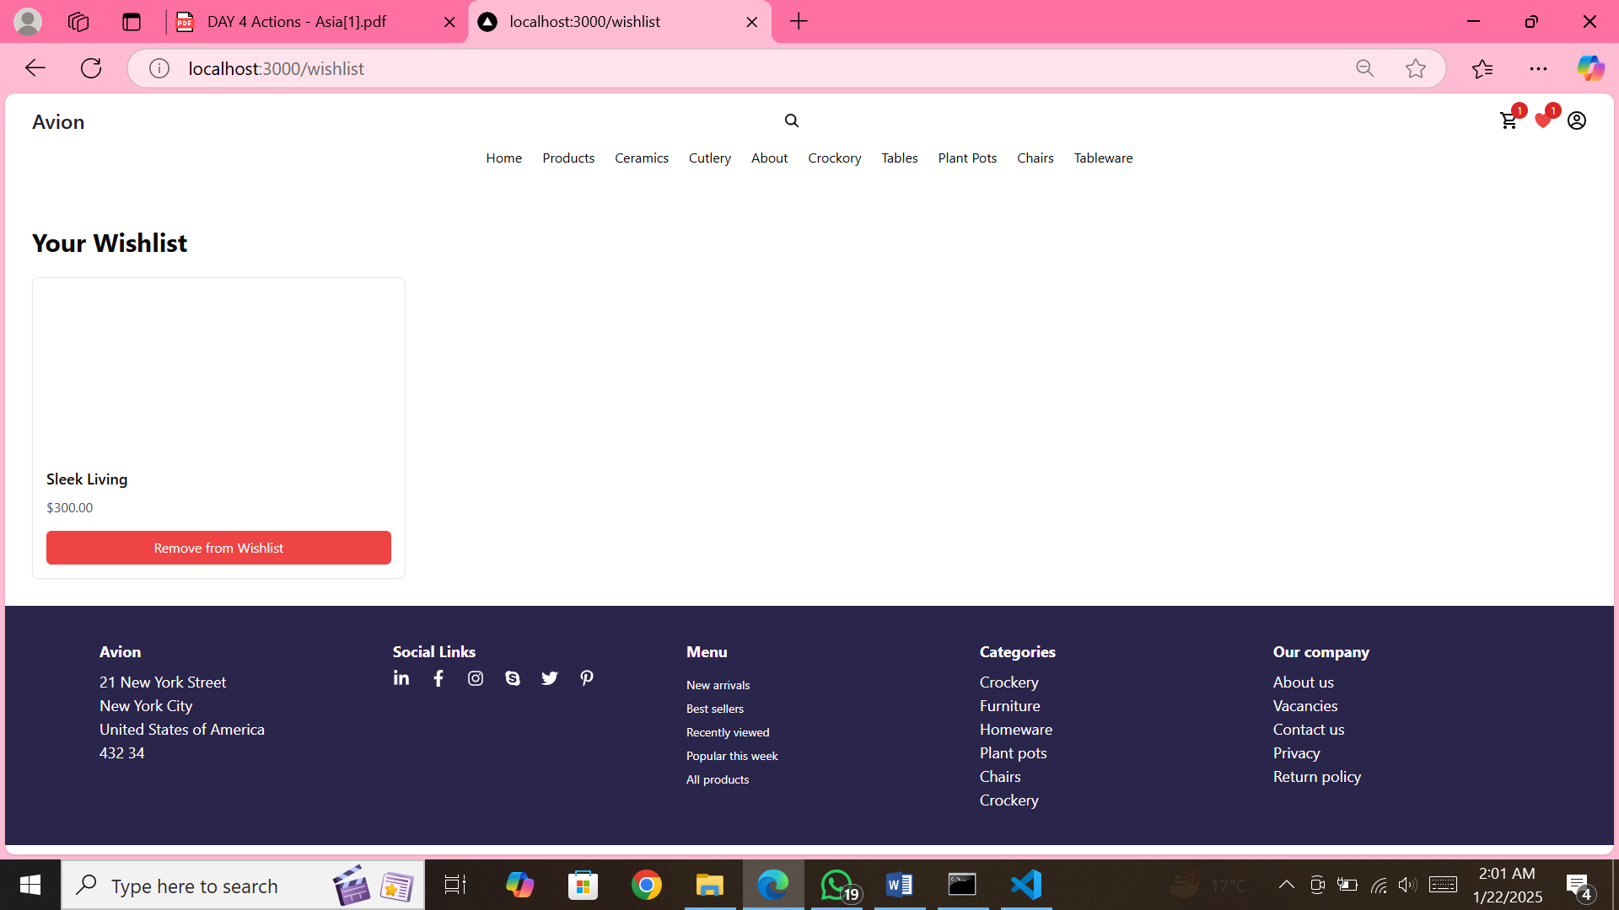

**DYNAMIC ROUTING:**

I also add dynamic routing to avion website.

